



**Kulliyyah OF Information & Communication Technology**

INFO3401–HUMANCOMPUTER INTERACTION

GROUP ASSIGNMENT 1

**Submitted To: Dr. Madihah S. Abd. Aziz**

**Submitted by:**

**MD. Afique Amin Zian. 1631005**

**Nasik Sami khan. 1638153**

**Md Arian Rahman. 1427517**

**Asif Mujtoba Newaz z 1520071**

**Mohamed Lahmed Ahmedou 1711957**

**Date of Submission: 24/10/2018**

**Table Of Content:**

|  |  |  |
| --- | --- | --- |
| Sr no | Topic | Page |
| 1 | Introduction (website, usage of the website, snapshot of the website, target users) | 1-4 |
| 2 | Discussions on the principles violated in the website. | 5 |
| 3 | Implications of your proposed design | 6 |
| 4 | Improved UI sketche | 7-12 |
| 5 | Methods used in the evaluation, interview questions | 13 |
| 6 | Finding from the evaluation | 14 |
| 7 | Conclusion | 15 |
| 8 | References | 15 |
| 9 | Interview transcriptions | 16-21 |

1. **Introduction:**

Accessibility is very important for designers, developers and organizations that want to create a high quality website/mobile application that did not exclude any particular group of people despite of their disabilities. We are require to enhance the accessibility of a website/mobile application based on your understanding of the principles of Inclusive Design or Universal Design.

The website that we choose to enhance the design accessibility is [**http://www.nile.com.my/**](http://www.nile.com.my/)

**About The website:**

**Nile.com.my** is a fast growing Malaysia Online Shopping portal. They strongly believe in always "**Prioritized Customer**" to ensure every RM the customers spent is worthy. The cost include man power, high material cost, multi layers intermediaries cost, rental and etc. Customers can online shopping at anywhere and anytime by just a click of mouse.

**Customer Experience:**

To ensure customer enjoy high satisfaction in online shopping, our purchasing team will always increase the products by directly import/purchase from manufacturer at a significantly bargained price and rewards it to our customers. We strongly practice [customer's priority], thus we have launched a [Cash On Delivery Services](http://www.nile.com.my/page.php?cd=24) in Kuala Lumpur and Petaling Jaya area for those who prefer C.O.D. Moreover, a tracking code will always be update to your email if you use courier services for your ease of tracking parcel.

**Usage of the website:**

As nile.com.my is mainly a website for online based shopping inside Malaysia, this website is used to buy the daily necessary products of the end users for example clothes for men , woman and kids, home and living things , groceries, health and beauty things ,digital and car accessories and things related with fashion. The website is very popular online shopping website inside Malaysia. The users just need to login with their own account and then buy whatever they actually need. For the payment it can be either using cash money or they can also pay with their cards .There is also a section called user guide to help the users knowing about the website.

1

**Target users:**

The main target users of this website are adult. Because they know much about the online shopping. But for our project of enhancing accessibility of this website we set the target users

1. Adult and older adult (60 years old and above)

**Snapshot of the Website:**

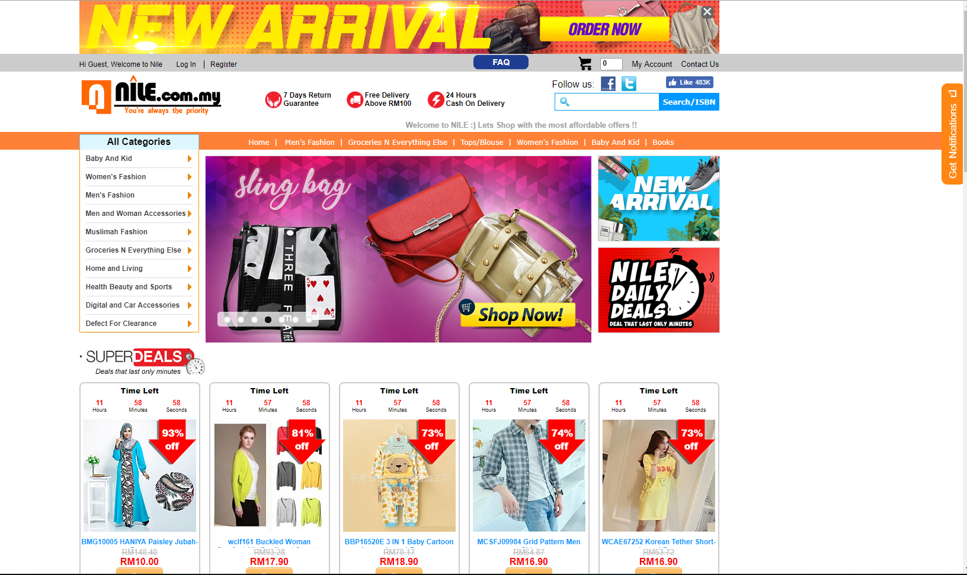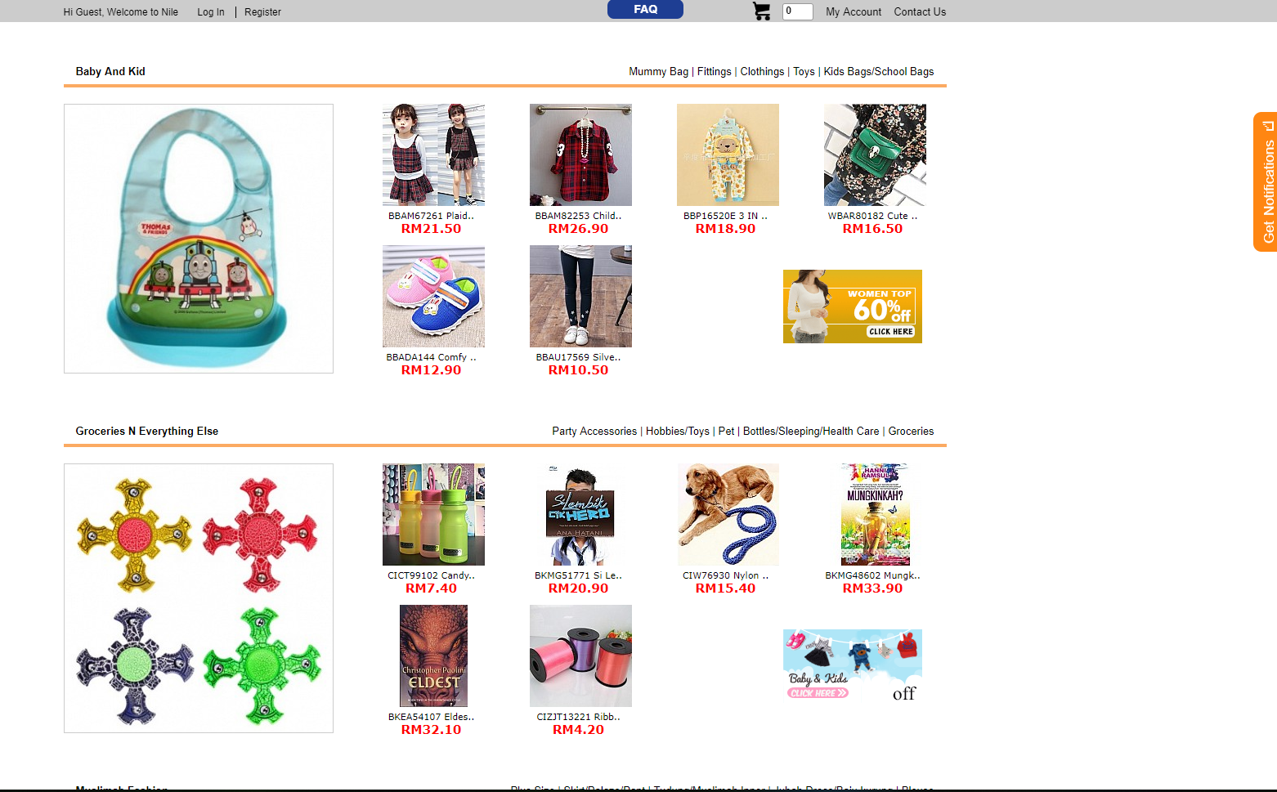

2

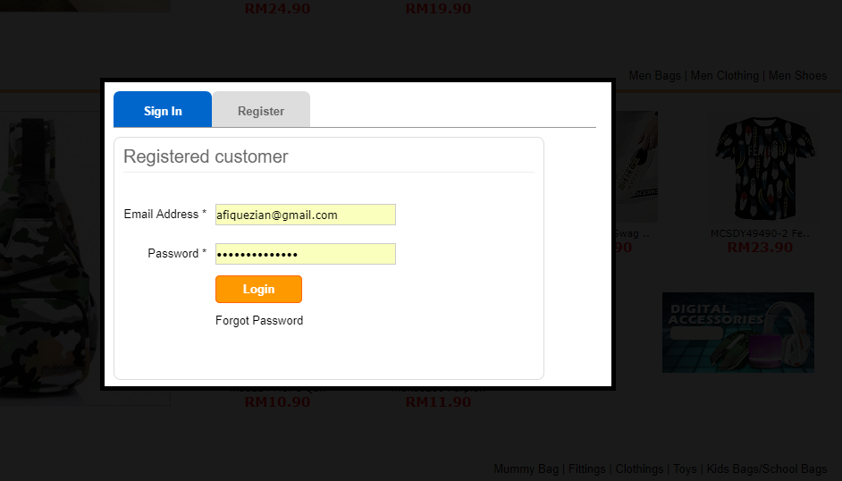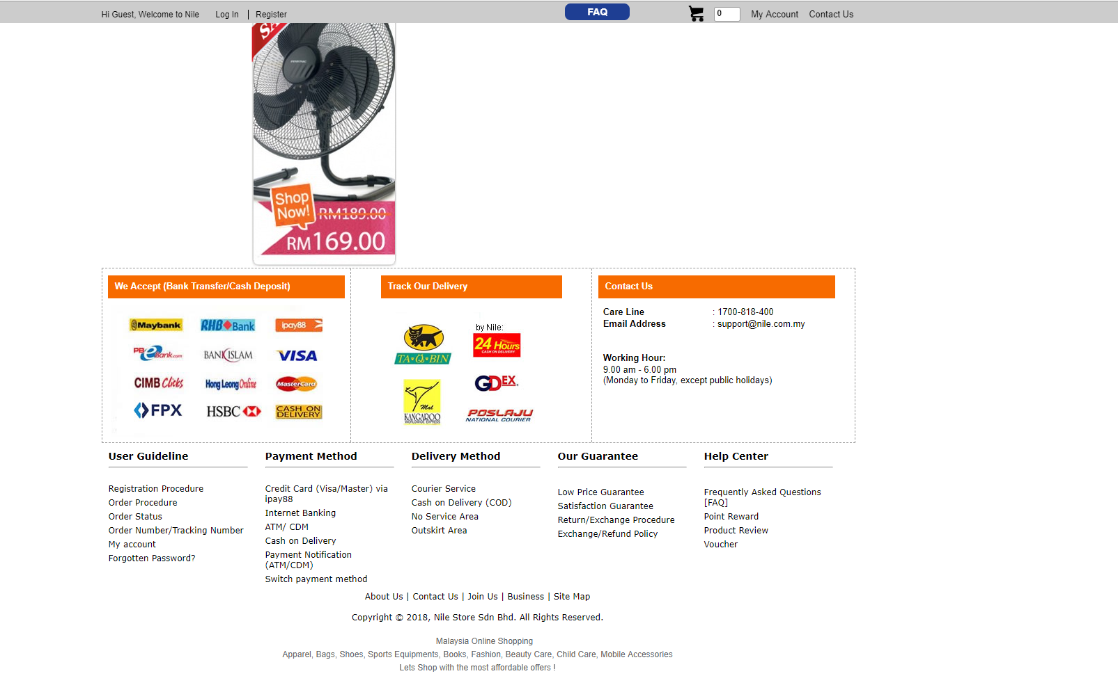

3

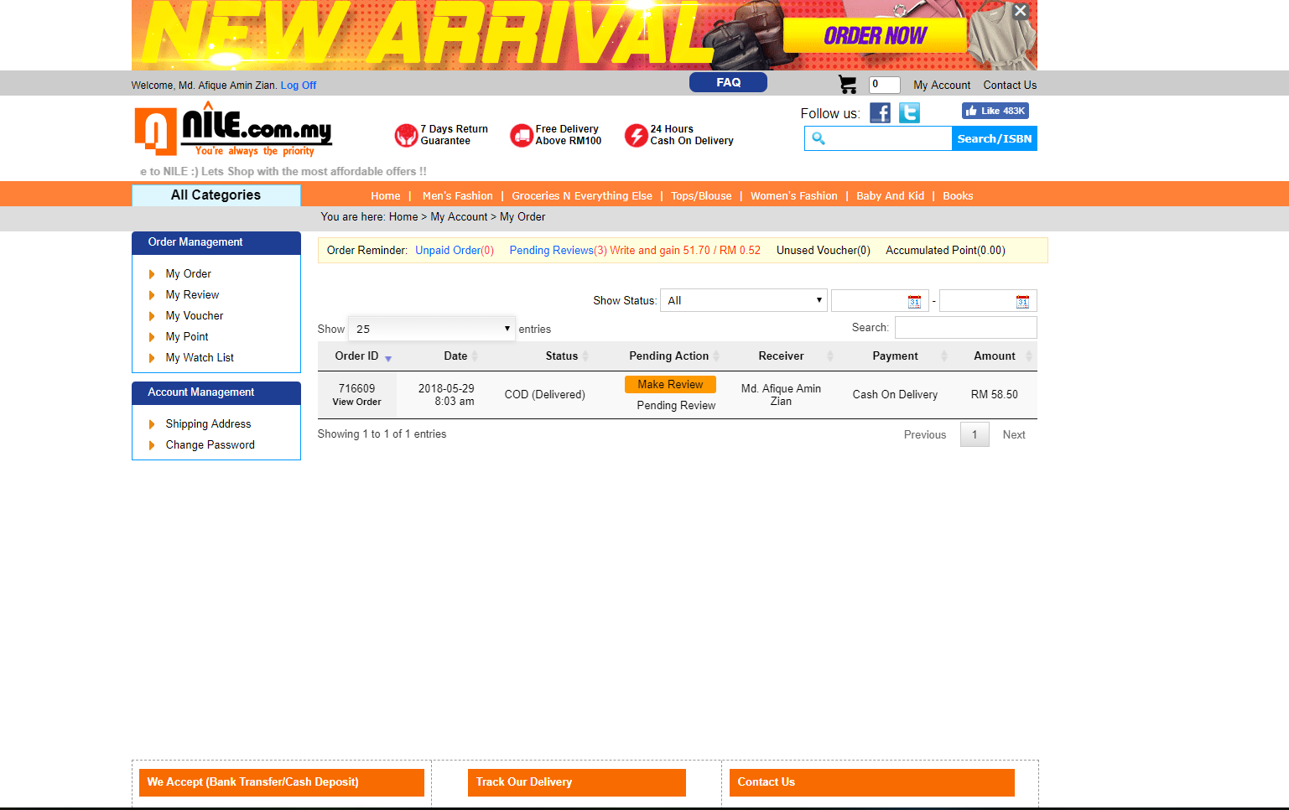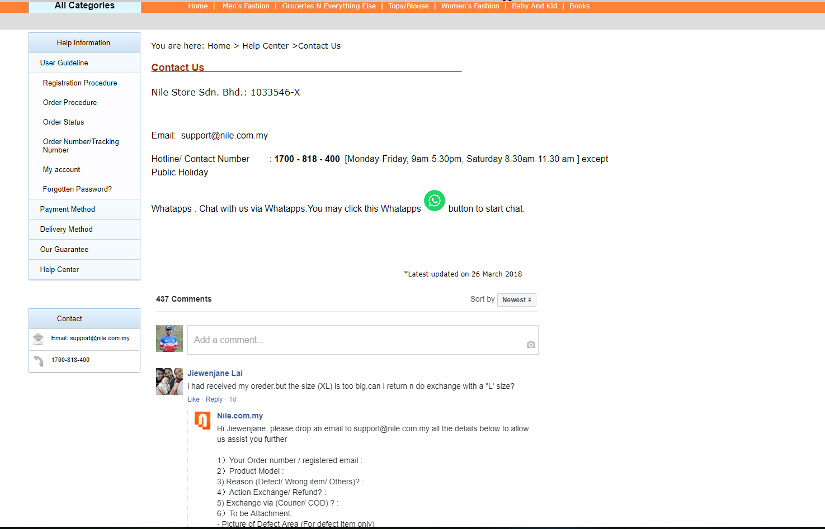

4

**2. Discussions on the principles violated in the website.**

In this assignment, as we are require to enhance the accessibility of a website/mobile application based on your understanding of the **principles of Inclusive Design or Universal Design.**

We can see that the main violated principles in this existing website are perceptible information, flexibility in use, simple and intuitive and Size and space for approach and use. The most important thing is that elderly people are not interested in such a website which is not flexible in use. The design problem of this website is do not categorize properly, using of the font and colour are not appropriate.

Here are the principles that are violated in our website:

1. Menu bar is not looking in the menu/ not focused. (**Offer different ways to engage**) which means there should be an alternative way to increase the looking of the bar.
2. Top banner is destructing concentration of the customer. (**Perceptible information**)
3. Footer is not highlighted (**Size and Space**)
4. New arrival and other contents are looking same. (**The Repetition**)
5. Search button text and color should be changed. (**Flexibility in use**)
6. Too many content in a small space (**Simple and intuitive**). It violates the design and very hard to find thins easily.
7. No option for changing language. (**Simple and intuitive use**). So those who are not good at English will face difficulties.
8. There is no mobile application for the website.(**Flexibility in use**)
9. User profile is not visible/notable enough and cannot track order.
10. The cart doesn’t ask for confirmation. (**Tolerance for error**)
11. Color choosing is not good (**Consider situation**).
12. If you search for any items you have to type full name properly, which is not that much easier task .( **Make task completion easier)**
13. **Arrows and the cursor do not use properly to get the website properly.(visibility Constraints)**

**5**

**3. Implications of your proposed design:**

1. In our proposed design we offer different ways to engage for the Menu Bar .It will look more complete than before and the font and color will be more suitable comparison with the whole page.
2. The footer will look better in our proposed design and it will be easily highlighted.
3. New arrival and other contents will not look the same like before in the new sketches.
4. The contents are not in a small places rather it will be more categorized than before.
5. You can change the language of the website which is convenient to the end users.
6. We make the website more flexible by giving the chance to use it as a mobile application.
7. It will track the order and user profile will be notable in the new design.
8. The cart will ask for the confirmation message so that if by mistake user press the delete option it will ask the confirmation to delete the cart.
9. The design will help the user to make task competition more easier .Now If you search for any items you don’t need to type full name.
10. The new arrival items and search engine will sort properly so users can find things easily.

**4. Improved UI sketches:**

Turn the next page to see our new UI sketches:

6

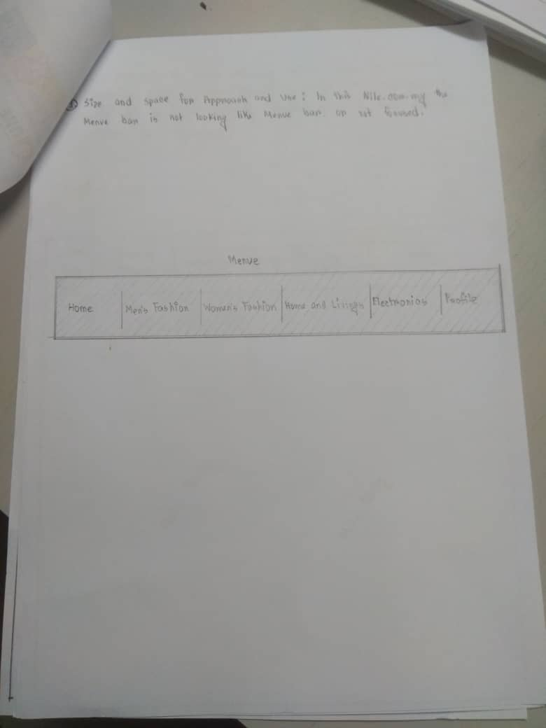

7

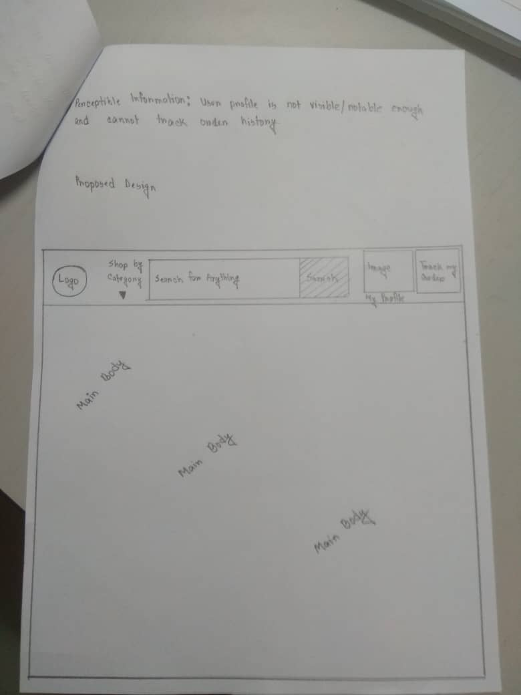

8

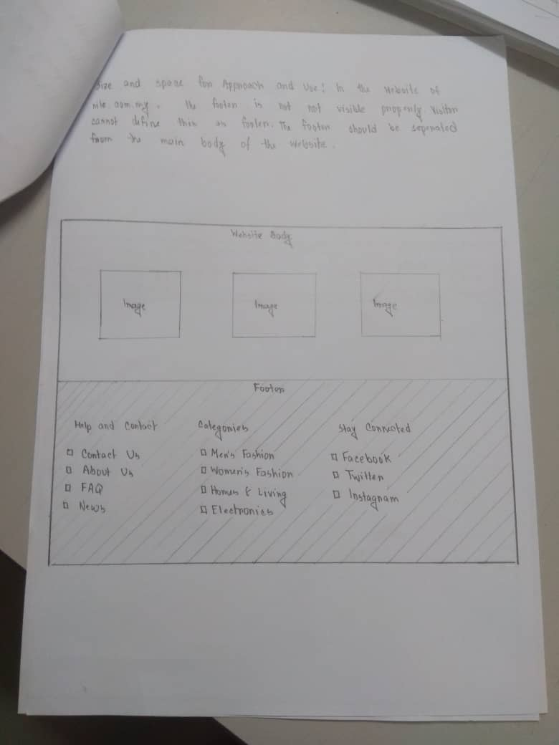l

9

l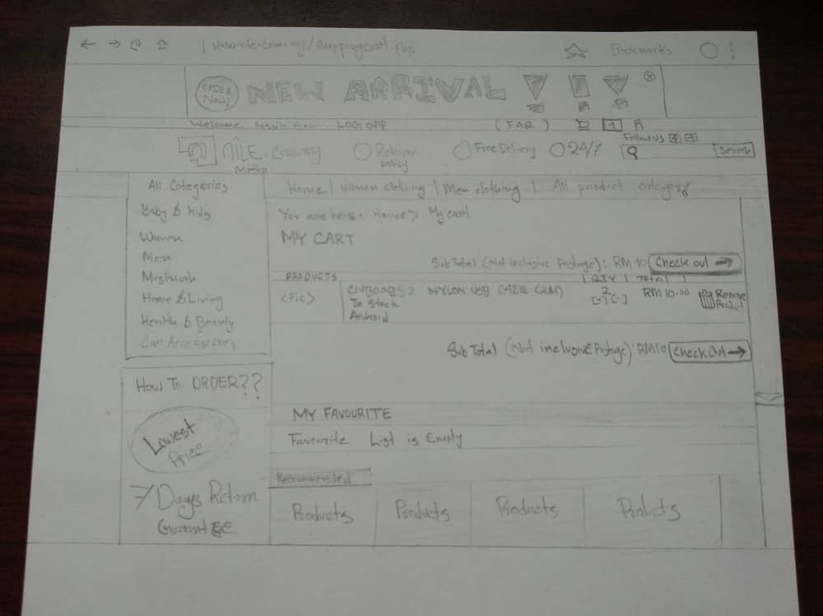

10

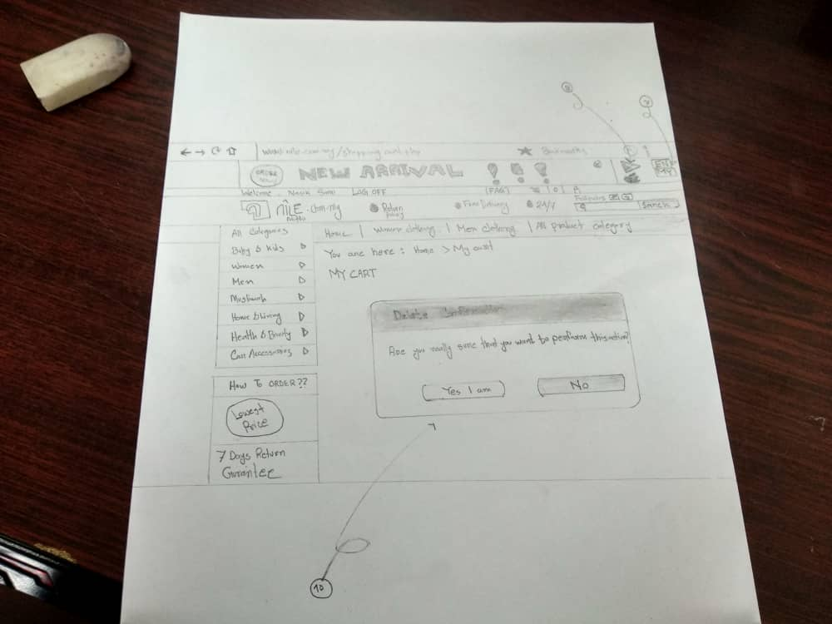

11

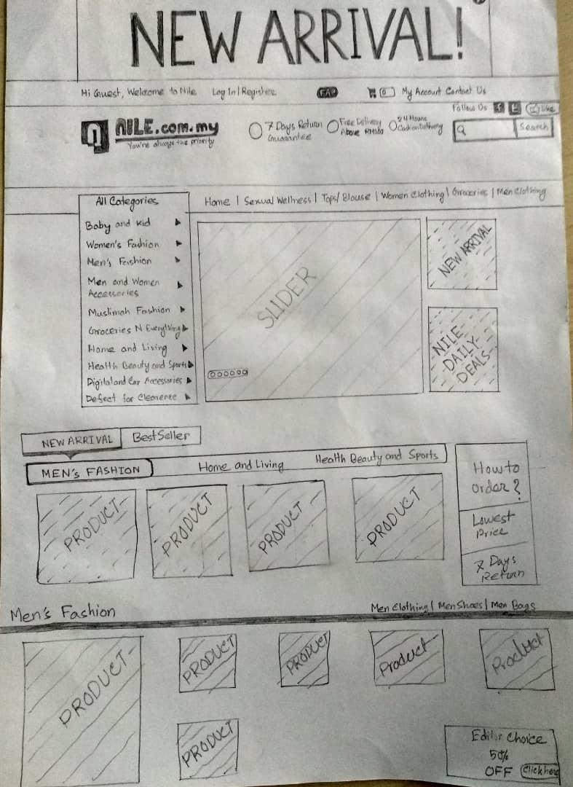

12

**5. Methods used in the evaluation, interview questions:**

For the evaluation we interviewed 3 people. We showed them the website, give them several tasks and after that we asked the questions as follows-

Part A:

1. Assalamu Alaikum brother/sister,Have you ever visited [www.nile.com](http://www.nile.com). If yes, then how was your experience working with this website.
2. If no, then can you just visit this website and order a product of your choice step by step and would you please inform us how it is?
3. Is the design is useful? Or appropriate?
4. Based on your experience how you mark this website on a scale 1-5(1=very unsatisfied, 2= unsatisfied, 3=neutral, 4-satisfied, 5=very satisfied). How much would you rate this website?
5. If you think, changes are needed then what will be the changes?

Part B:

1. This is the sketches that we have done in an alternative of the website. Would you please look at these sketches and tell us whether it fulfills your desire or need?
2. Based on your experience how you mark this website on a scale 1-5(1=very unsatisfied, 2= unsatisfied, 3=neutral, 4-satisfied, 5=very satisfied). How much would you rate this sketches?
3. Can you please Identify any additional requirements, and suggestions for improvement.
4. If your desires are fulfilled then how frequent will you use this website?

After asking the questions we had recorded the outcome from them. We also got recommendation from the interviewee.

13

**6. Finding from the evaluation:**

1. All the interviewers said that the design of the Nile.com is not so good.

2. The user interface is not user friendly.

3. Language option has to be there because everyone is not same good at English.

4. On the Nile.com there are some unnecessary things that are not understandable.

5. Also the navigation system of Nile.com has to change with active navigation system.

6. Need to modify the colour.

7. One interviewer suggested that we can use AI (Artificial Intelligence) so that we can get auto suggestion.

8. Another interviewer said that the website contents only for adult, so it is irritated for older people.

9. All the interviewers suggested that footer has to be simple and clear.

10. The search engine should appear in proper way and should give us the suggestion so we can find things easily.

14

**7. Conclusion:**

To sum up, nile.com has some problems with the UI design which are easily identified by the users. At a glance, users are able to clarify the problems of the nile.com shopping website and they suggested that it has to be changed. The categorization, the font and the colours are not used properly. Also the interviewers suggested the good design for the nile.com. So, we have proposed our sketch to take those suggestions from the interviewers. They really appreciate those. With this assignment so far, we have learnt about so many things. They are:

1. the good designs vs bad designs, there effects towards the users
2. Universal design principal and fundamental design principals
3. Searching for various websites and sorting out the violated design principals
4. Fixing the problem based on the principals
5. How to do low fidelity testing
6. Using a method and evaluate what we have gained

**8. References:**

1. <http://www.nile.com.my/index.php>
2. <https://inclusivedesignprinciples.org/>
3. <https://www.interaction-design.org/literature/article/bad-design-vs-good-design-5-examples-we-can-learn-frombad-design-vs-good-design-5-examples-we-can-learn-from-130706>
4. Benyon, D. (2013). Designing Interactive Systems: A Comprehensive Guide to HCI and Interaction Design, Addison-Wesley.
5. Dix, A., Finlay, J., Abowd, G. & Beale, R. (2004). Human computer interaction, (3rd ed.), USA: Pearson-Prentice Hall.
6. <https://www.interaction-design.org/literature/article/bad-design-vs-good-design-5-examples-we-can-learn-frombad-design-vs-good-design-5-examples-we-can-learn-from-130706>

15

**8. Interview transcriptions:**

**Interview 1**

**Youtube Link:** https://youtu.be/dtSVyPl_Ka8

**Interviewer:** Assalamualiakum wrt.wbr brother.

Interviewee: Walaikum Assalam Wrt.wbr.

**Interviewer:** Have you ever visited [www.nile.com](http://www.nile.com). If yes, then how was your experience working with this website.

Interviewee: No I have heard about it but I never visited.

**Interviewer:** Can u just visit this website and make an order then let us know how was your experience?

Interviewee: The design is not really good one. It is little bit confusing. You know like amazon or e-bay everything is categorized but here it’s little bit messy and not that much simple. And also the using of font is not good here.

**Interviewer:** ok! Based on your experience how you mark this website on a scale 1-5(1=very unsatisfied, 2= unsatisfied, 3=neutral, 4-satisfied, 5=very satisfied). How much would you rate this website?

Interviewee: Because of the navigation and other things is not that much good but it’s okay I can order somehow so I will give 3 out of 5.

**Interviewer:** Do you think there should be other changes based on the design?

Interviewee: Yes of course. It should be simple and more categorized so that people can find easily.

16

**Part B:**

**Interviewer:** Okay. This is the sketches that we have done in an alternative of the website. Would you please look at these sketches and tell us whether it fulfills your desire or need?

Interviewee: Ya! I can see it’s very improved now than before. The navigation is good and it looks more categorized and good looking. And the footer is also visible and easily notable here. So it’s a good design undoubtedly. It’s lot better

It fixes the main issues that I found when I visited the original site.

**Interviewer:** Based on your experience how you mark this website on a scale 1-5(1=very unsatisfied, 2= unsatisfied, 3=neutral, 4-satisfied, 5=very satisfied). How much would you rate this sketches?

Interviewee: I will give 4.

**Interviewer:** Can you please Identify any additional requirements, and suggestions for improvement.

Interviewee: Just little. Compare to Amazon or other website they use other technologies like artificial intelligence so maybe you can also include this in your design so it will be more usable.

**Interviewer:** ok! That’s the end .Thank you so much for your co-operation.

Interviewee: ok! Thanks

17

**Interview 2 :**

**Youtube Link: https://youtu.be/YvL6CS12f1I**

**Part A:**

**Interviewer:** Assalamualiakum wrt.wbr brother.

Interviewee: Walaikum Assalam Wrt.wbr.

**Interviewer:** Have you ever visited [www.nile.com](http://www.nile.com).my If yes, then how was your experience working with this website.

Interviewee: Yes, I have visited. But I never shopped anything from nile.com.

**Interviewer:** Can u just visit this website and make an order then let us know how was your experience?

Interviewee: So far I use the website, I feels problem with the transaction part and also the colour combination is not that much good to visualize. They can change the colour here and also the font size.

**Interviewer:** ok! Based on your experience how you mark this website on a scale 1-5(1=very unsatisfied, 2= unsatisfied, 3=neutral, 4-satisfied, 5=very satisfied). How much would you rate this website?

Interviewee: On the scale of 1-5. I will rate this website 3. As I have told u the colour and the font size is not perfect for the users.

**Interviewer:** Do you think there should be other changes based on the design?

Interviewee: Yes of course. It should be simple and more categorized so that people can find easily.

**Part B:**

**Interviewer:** Okay. This is the sketches that we have done in an alternative of the website. Would you please look at these sketches and tell us whether it fulfil your desire or need?

18

Interviewee: Ya! I can see it’s very improved now than before. You have changed the colour so far it looks good. You have redesigned the cart system that also looks nice. Its more reliable than the original one to me. Also here I can identify the footer it is also a great change.

**Interviewer:** Can you please Identify any additional requirements, and suggestions for improvement?

Interviewee: Yes, I think just work with the categorization, the font and sizes will make it more reliable. The website contents only for adult, so it is irritated for older people. You can work with that also.

**Interviewer:** ok! That’s the end .Thank you so much for your co-operation.

Interviewee: ok! Thanks

19

**Interview 3 :**

**Part A:**

**Interviewer:** Assalamualiakum wrt.wbr brother.

Interviewee: Walaikum Assalam Wrt.wbr.

**Interviewer:** Have you ever visited [www.nile.com](http://www.nile.com)? If yes, then how was your experience working with this website.

Interviewee: Yes I have visited the website few month ago but I forgot about the experience. So I need to check it again.

Interviewer: So can you please do it once again?

Interviewee: Yes, I have visited and the experience was not that good. It was difficult for me to find the search engine and when I found it there was no suggestion in the search engine . so that’s a problem. Also the sorting was not good of the website. And the font also. The new arrival items need to be sorted appropriately.

**Interviewer:** ok! Based on your experience how you mark this website on a scale 1-5(1=very unsatisfied, 2= unsatisfied, 3=neutral, 4-satisfied, 5=very satisfied). How much would you rate this website?

Interviewee: Because of the search engine and other things is not that much good I will give 3 out of 5.

**Interviewer**: Do you think there should be other changes based on the design?

Interviewee: Yes of course. It should be look good and sorted properly and more categorized so that people can find easily. The search engine should give us more suggestion.

20

**Part B:**

**Interviewer:** Okay. This is the sketches that we have done in an alternative of the website. Would you please look at these sketches and tell us whether it fulfills your desire or need?

**I**nterviewee**:** Yes now I can see the sketches are far better than the original one. You have worked with the homepage and sorted the new arrival properly. Also the navigation icons are look good. Wait what do u mean to say by this apple Icon here?

**Interviewer:** It means now you can use it also as an android apps.

Interviewee**:** woow good .You also work with the language I can see that. Very good sketches.

**Interviewer:** Based on your experience how you mark this website on a scale 1-5(1=very unsatisfied, 2= unsatisfied, 3=neutral, 4-satisfied, 5=very satisfied). How much would you rate this sketches?

Interviewee: I will give 4.5.

**Interviewer**: Can you please Identify any additional requirements, and suggestions for improvement.

Interviewee: I think now its okay so no need any other additional requirements.

**Interviewer:** ok! That’s the end .Thank you so much for your co-operation.

Interviewee: ok! Thanks

**Final Youtube link:**

Combination of three videos: **https://youtu.be/WTpioIM8fL**

………………END………….

21